**BRAC UNIVERSITY**

**Department of Computer Science and Engineering**

**CSE420: Compiler Design**

**Quiz 02, Spring 2016**

**Duration: 1.00 hours, Total Marks: 35**

|  |
| --- |
| Student Name:  Student ID:  Section: |

**1.** What is L-attributed definition? “Every S-attributed definition is L-attributed” – Justify your answer. **[1+1]**

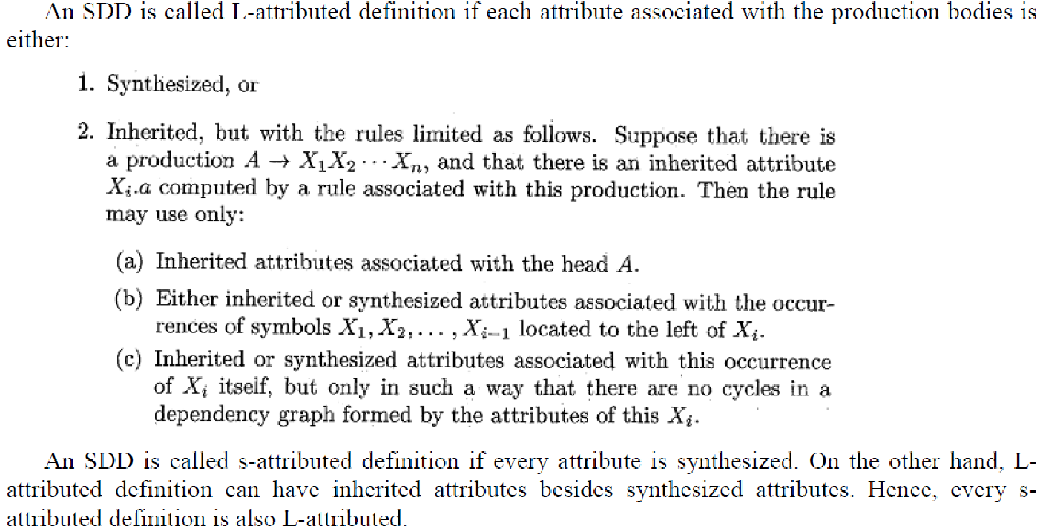

**3.** A syntax directed definition for declaring identifiers is:

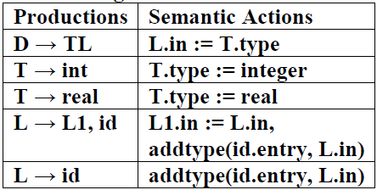

i) Draw an annotated parse tree for the sentence: integer a, b, c

ii) Draw the dependency graph for the parse tree of (i). **[4 + 2]**

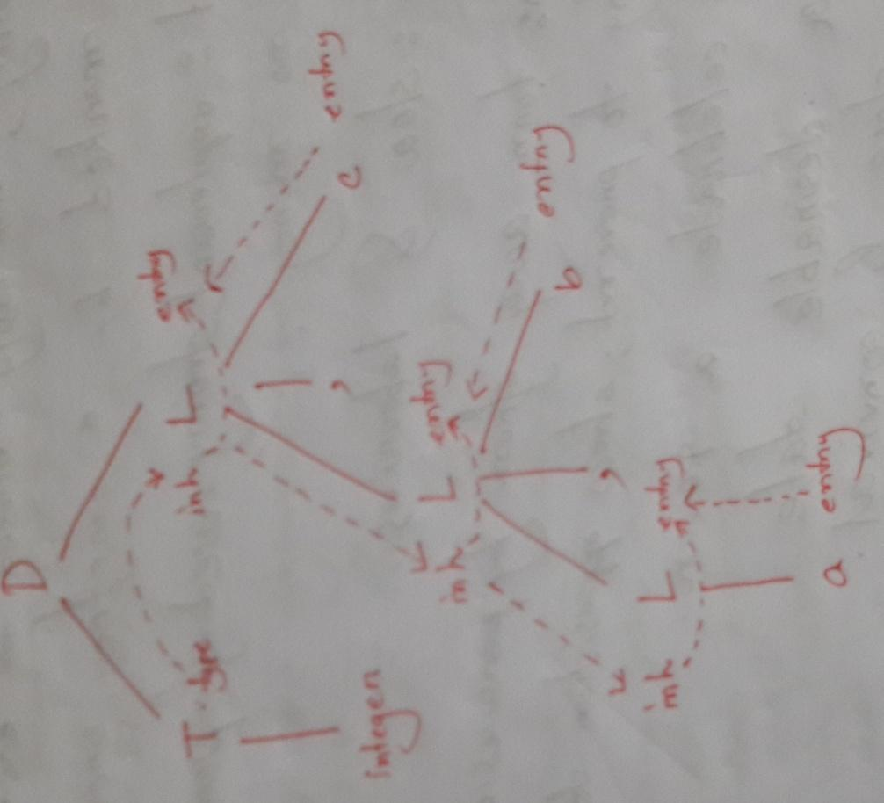

**4.** Translate the expression (a[i]+b)*c into: **[3+2]**

i) Quadruples,

ii) Triples,

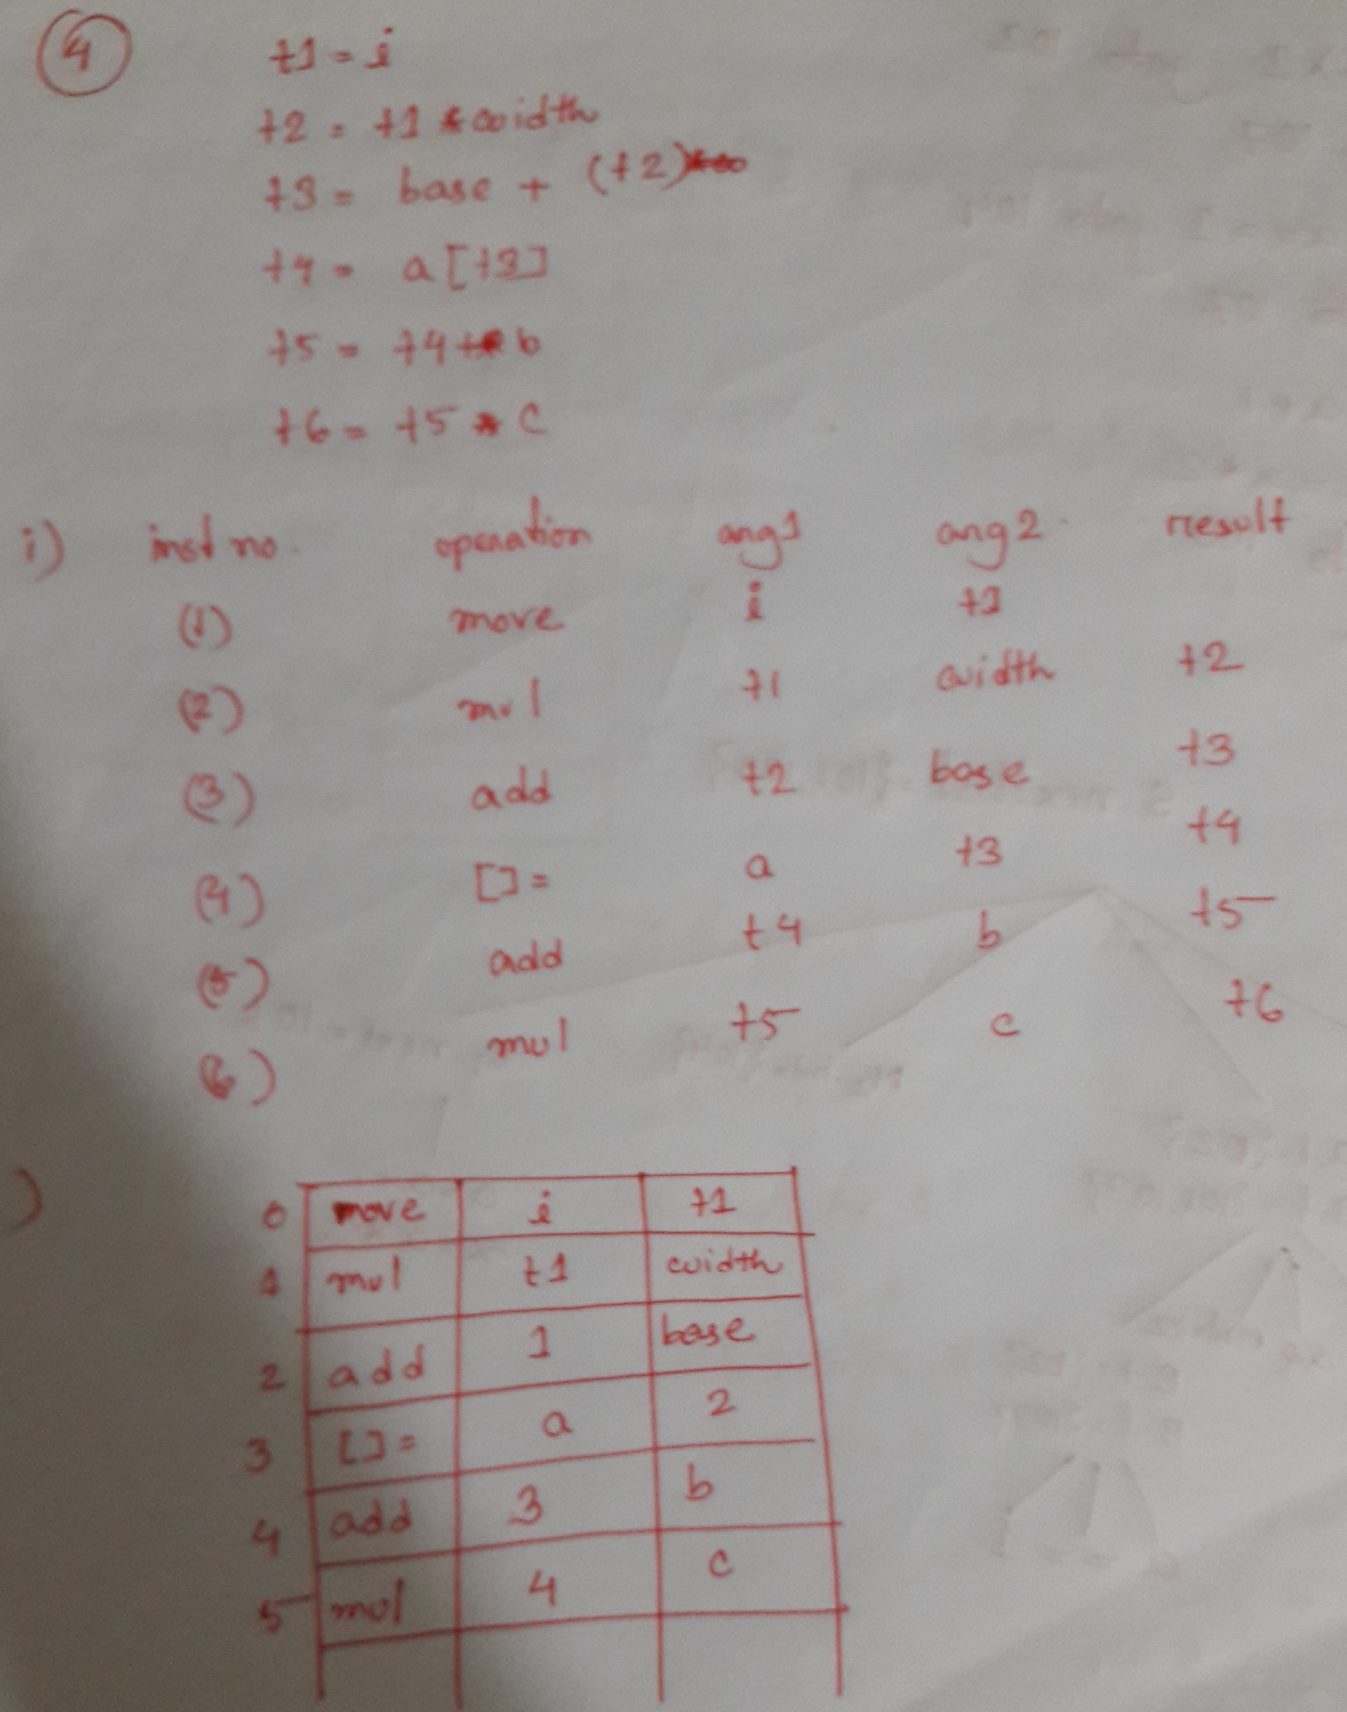

**5.** Determine the target statements of following code segment using the techniques of back-patching: **[6]**

|  |
| --- |
| while (a>2 && a==1) {  a=a+1;  x=a*2;  }  System.out.println(a+” ”+x); |

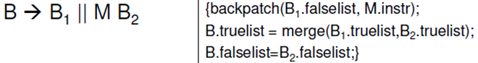

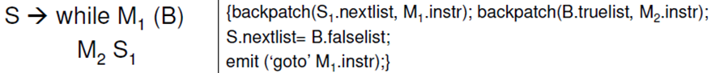

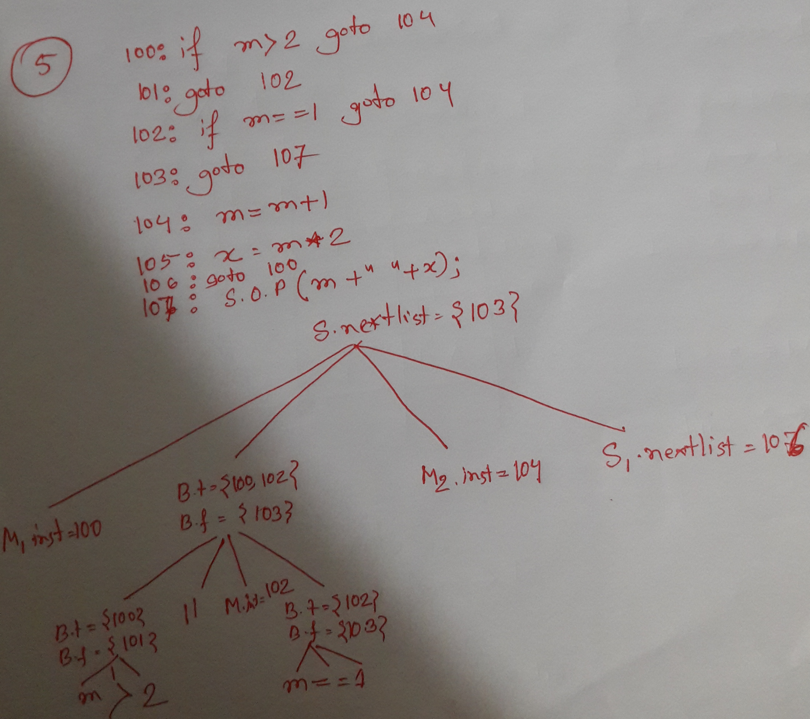

**6.** Draw the block diagrams of following control flow statements: **[4]**

***S -> if( (a>2 && a<6) || a%2==0) x = x+a;***

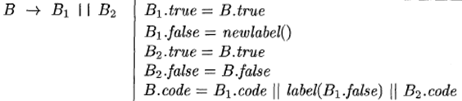

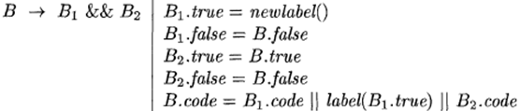

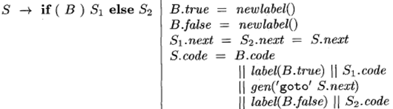

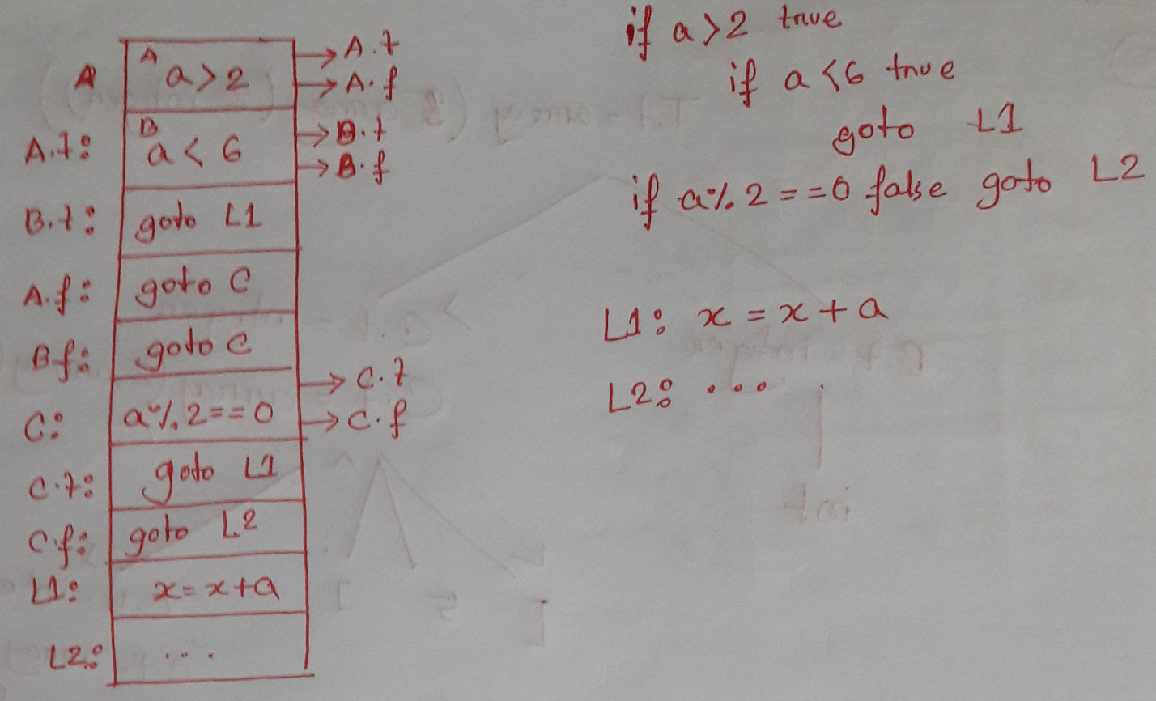

**7.** Construct the LR(1) items and LALR automation of following productions: **[6+2]**

S-> Aa

S-> bAc

S-> bBa

A->d

B->d

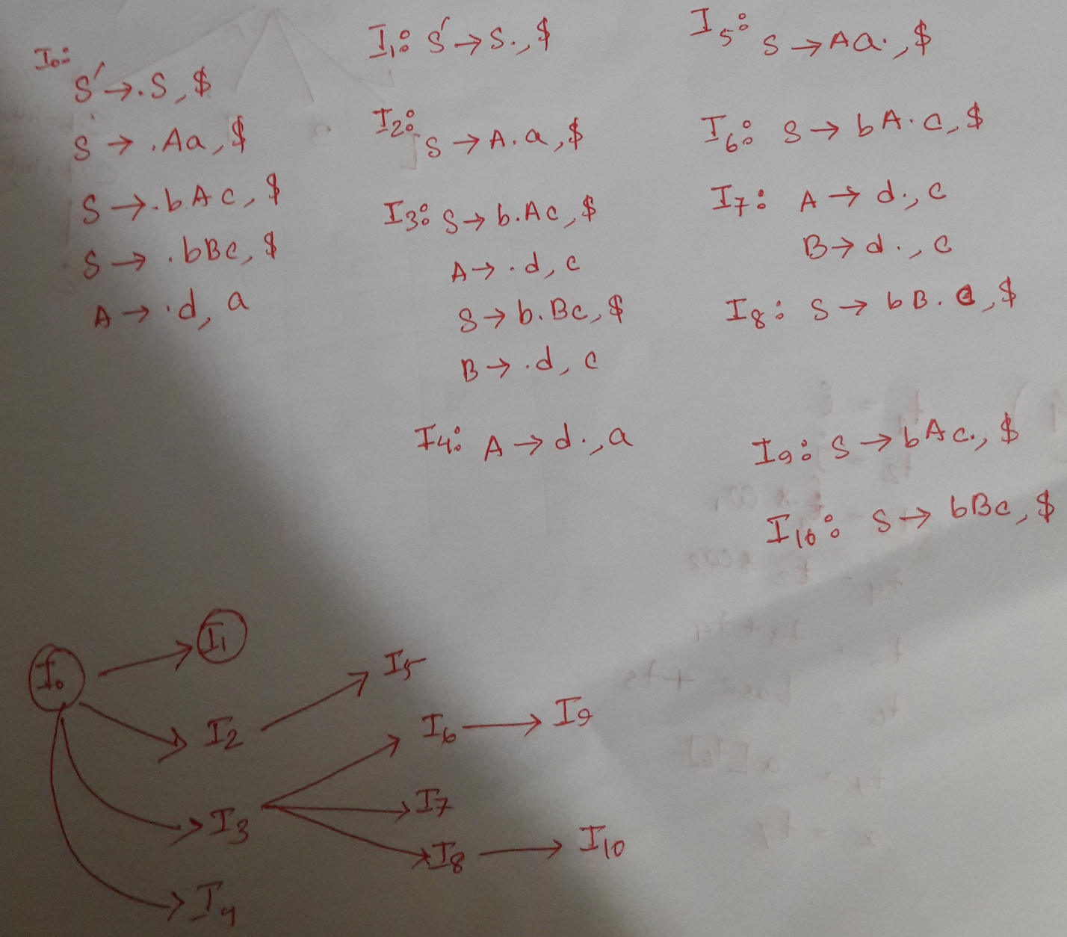

**8.** State the major functions of Back-patching. **[1]**

**makelist(i)**

Merge(p1,p2)

Backpatch(p,i)